**Instruction for writing project Report:**

1. Font type (Times New Roman) must be same as in this report.
2. Index for figures and tables must be separate as given in project.
3. If figure or table comes in chapter one then title will be Figure 1.1, Figure1.2, ... so on and Table 1.1, Table 2.1,..so on. For chapter two Figure 2.1, Figure 2.2,…and Table 2.1, Table 2.2,…. and so on.
4. Normal Text of font Size 12 in Times New Roman font style, not bold and justify format(Ctrl z).
5. Chapter number and name with font size 16 in Times New Roman font style (Bold letters, each letter is in Uppercase, aligned to centre).
6. Main Heading of chapters are with font size 14 in Times New Roman font style (Bold letters, each letter is in Uppercase and justify format (Ctrl z)).
7. Sub heading of chapters are with font size 12 in Times New Roman font style (without Bold, each word is in sentence case and justify format (Ctrl z)).
8. Code of project must be added as part of appendix.
9. Snapshot must be taken from running project.

**PROJECT REPORT**

**TITLE**

**Submitted in partial fulfilment of the requirement for the award of the degree of**

**BACHELOR OF TECHNOLOGY**

**IN**

**COMPUTER SCIENCE & ENGINEERING - Specialization**

***Submitted by***

**NAME1 University Roll No-**

**NAME2**

**Under the guidance of**

*Mr. XYZ*

*DESIGNATION*

**Project Group No:**



**Department of Computer Science and Engineering**

**Graphic Era Hill University**

**June, 2025**



**CANDIDATE’S DECLARATION**

I/We hereby certify that the work which is being presented in the project progress report entitled **“Title of the project”** in partial fulfillment of the requirements for the award of the Degree of Bachelor of Technology in Computer Science and Engineering **- Specialization** in the Department of Computer Science and Engineering of the Graphic Era Hill University, Dehradun shall be carried out by the undersigned under the supervision of **Guide Name, Designation**, Department of Computer Science and Engineering, Graphic Era Hill University, Dehradun.

Name1 University Roll no1 **signature**

Name2 University Roll no2 **signature**

The above mentioned students shall be working under the supervision of the undersigned on the **“Title of the project”**

**Guide** **Head of the Department**

**Date**

**Place**

**ACKNOWLEDGEMENT**

Thanks to Mr. Bill Gates for creating Microsoft Word and with it an easy-to-use word processor. Use your own language.

**Name of student 1 Name of student 2**

Roll no. Roll no.

**ABSTRACT**

A simple template is provided here in MS Word class. This can be used to easily write a thesis suitable for submission at GEHU. The class provides options for B.Tech.

The formatting is (to the best of knowledge of the authors) as per the guidelines of the institute.

**TABLE OF CONTENTS**

**ACKNOWLEDGEMENT i**

**ABSTRACT ii**

**LIST OF TABLES iv**

**LIST OF FIGURES v**

**ABBREVIATIONS vi**

**NOTATIONS vii**

# INTRODUCTION 1

## MS Word features………………………………….……………….................... 2

## MS Word figures……………………………………………………………….. 2

## MS Word options………………………………………………………………. . 2

# REQUIREMENT ANALYSIS

2.1----

# A SAMPLE APPENDIX 3

**LIST OF TABLES**

## A sample table with table caption placed appropriately. This caption is very long and is single-spaced. Notice how the text is aligned……..…………….4

**LIST OF FIGURES**

## A sample figure with figure title placed appropriately. This title is very long and is single-spaced. Notice how the text is aligned……..…………….4

**ABBREVIATIONS**

GEHU Graphic Era Hill University

MWW Microsoft Word is Wonderful

**NOTATIONS**

*α* Scale parameter

*β* Depth angle in degrees

# CHAPTER 1

(SAME FORMAT FOR OTHER CHAPTER)

# INTRODUCTION AND MOTIVATION – 3 to 4 pages

# (OR ANY OTHER HEADING)

This is the first chapter of the thesis/dissertation template. This is to indicate the formatting style of the report. The line spacing is 1.5, with the indent at the new paragraph.

The new paragraph can start in the next line, with no gap. There is an indentation of 0.2” at the beginning of the paragraph. Paragraph in the thesis will always be justified, not left-centered.

## **MS Word features**

A new section paragraph starts with no indentation. However, there will be a regular indentation of 0.2” at the start of next paragraph.

If we want to insert a figure in the text, it has to be centered and suitable title be added for the same. For example,

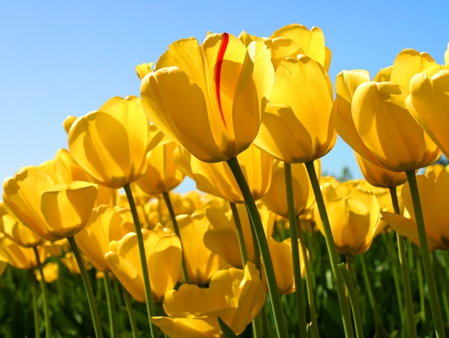

# CHAPTER 2

# OBJECTIVES OR PROBLEM STATEMENT

Point wise explanation of each objective

# CHAPTER 3

# project methodology / design

# ( Algo and blue print should be included in this chapter with proper diagram)

This section may include architectural design of the project, implementation of any objectives, pseudo code/ algorithms, discussion of the results, etc.

# CHAPTER 4

# RESULT AND IMPLEMENTATION

The new paragraph can start in the next line, with no gap. There is an indentation of 0.2” at the beginning of the paragraph. Paragraph in the thesis will always be justified, not left-centered.

# CHAPTER 5

# Conclusion AND fUTURE SCOpe

The new paragraph can start in the next line, with no gap. There is an indentation of 0.2” at the beginning of the paragraph. Paragraph in the thesis will always be justified, not left-centered.

**APPENDIX A**

**(Code)**

It will contain code of project/software.

**References**

[1] Ji, XunSheng, et al. "Application of the digital signal procession in the MEMS gyroscope de-drift." *Nano/Micro Engineered and Molecular Systems, 2006. NEMS'06. 1st IEEE International Conference on*. IEEE, 2006.

[2] Nussbaumer, Henri J., and Martin Vetterli. "Computationally efficient QMF filter banks." *Acoustics, Speech, and Signal Processing, IEEE International Conference on ICASSP'84.*. Vol. 9. IEEE, 1984.

Sites those you used

Any other reference

**Publications**

**(if any)**

[1] Ji, XunSheng, et al. "Application of the digital signal procession in the MEMS gyroscope de-drift." *Nano/Micro Engineered and Molecular Systems, 2006. NEMS'06. 1st IEEE International Conference on*. IEEE, 2006.